TASK#01
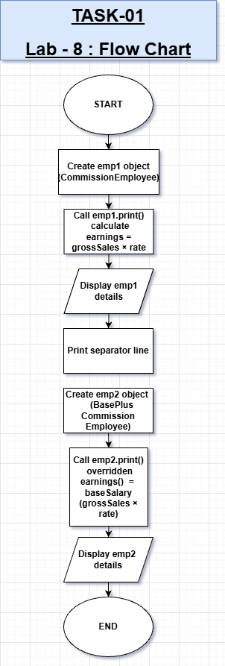

Task 01 – Description

This task implements inheritance by creating a CommissionEmployee base class and a BasePlusCommissionEmployee derived class. It demonstrates code reuse and method overriding to calculate earnings including base salary and commission.

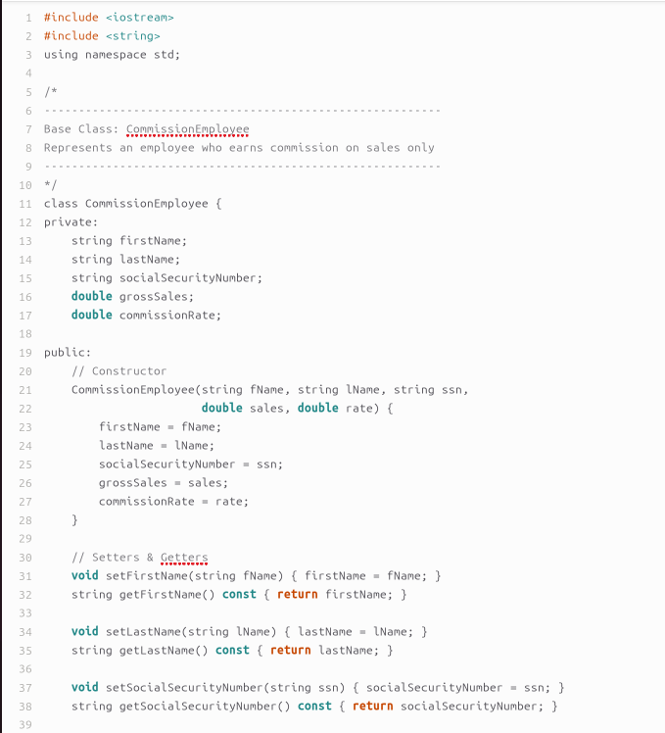
CODE

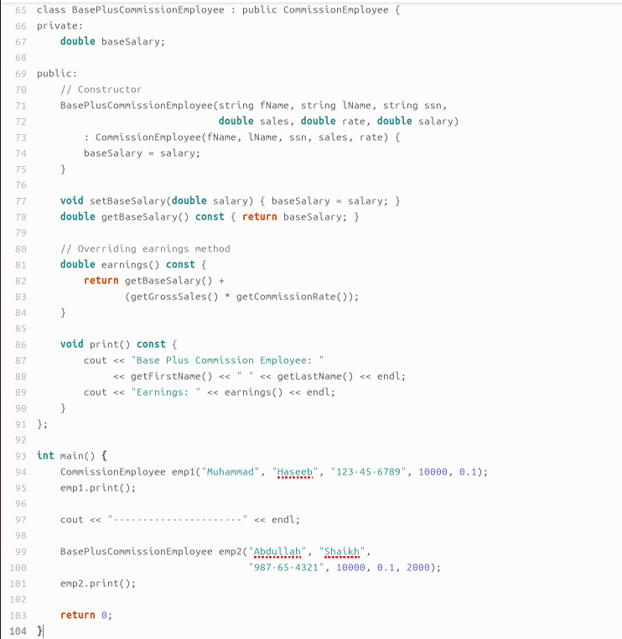
CODE

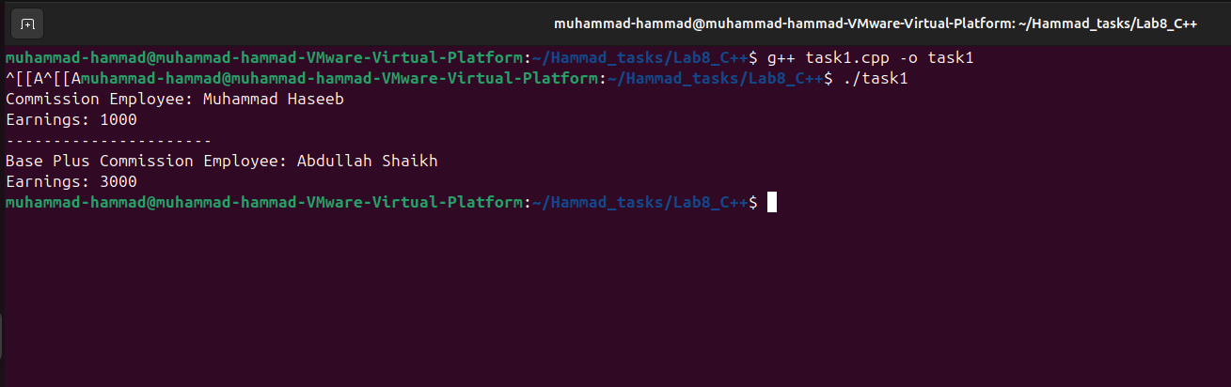
OUTPUT

TASK#02

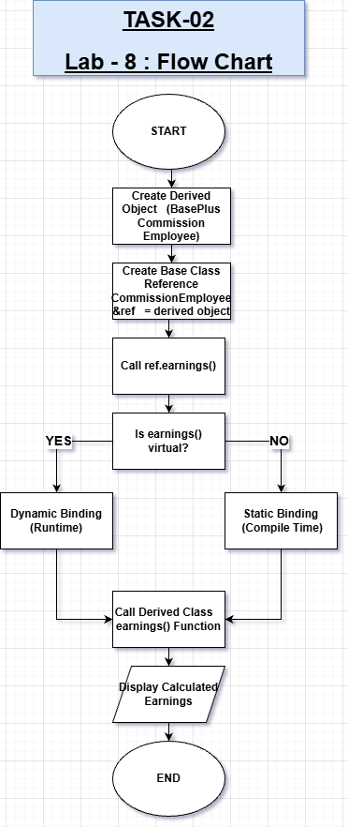

Task 02 – Description
This task demonstrates runtime polymorphism by declaring the earnings() function as virtual in the base class. A base class reference pointing to a derived object ensures that the derived class method is called through dynamic binding.

TASK#02 CODE
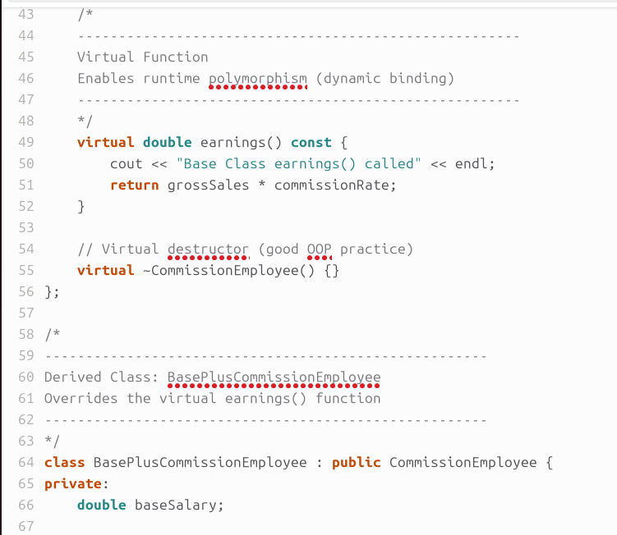

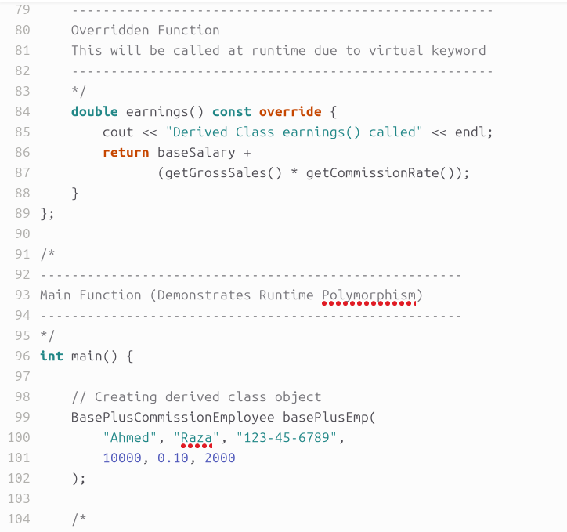

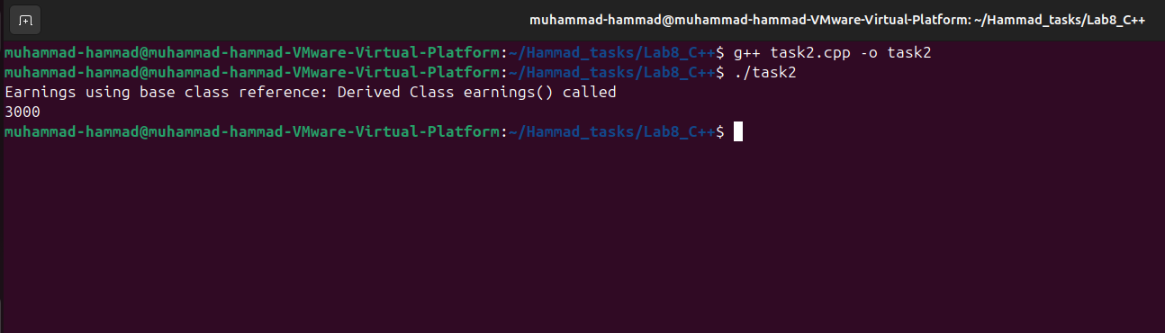
OUTPUT

TASK#03

Task 03 – Description
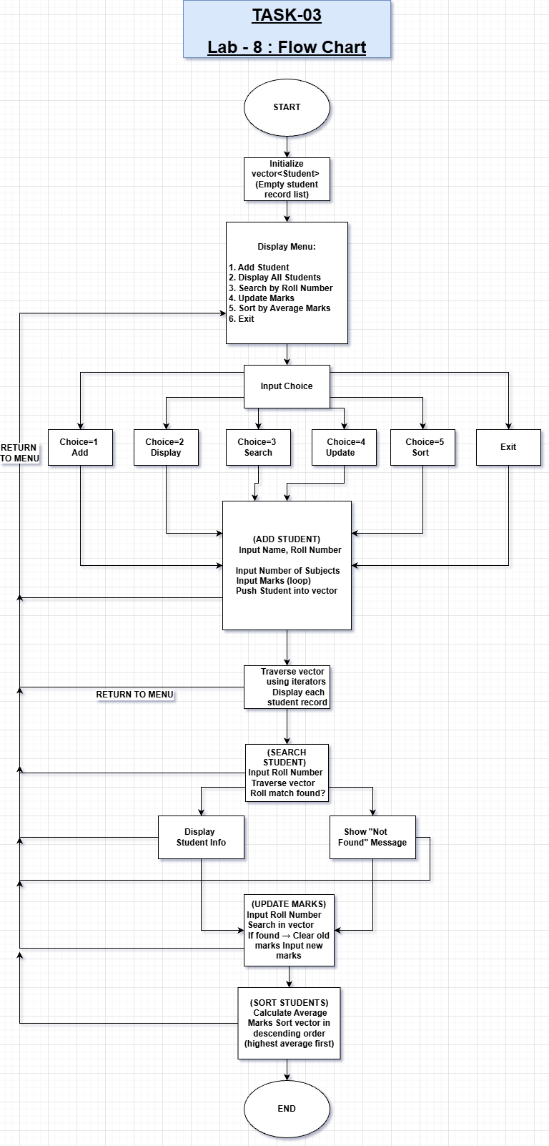
This task develops a menu-driven Student Record Management System using std::vector to store multiple student objects. It performs operations like adding, searching, updating, displaying, and sorting student records based on average marks.

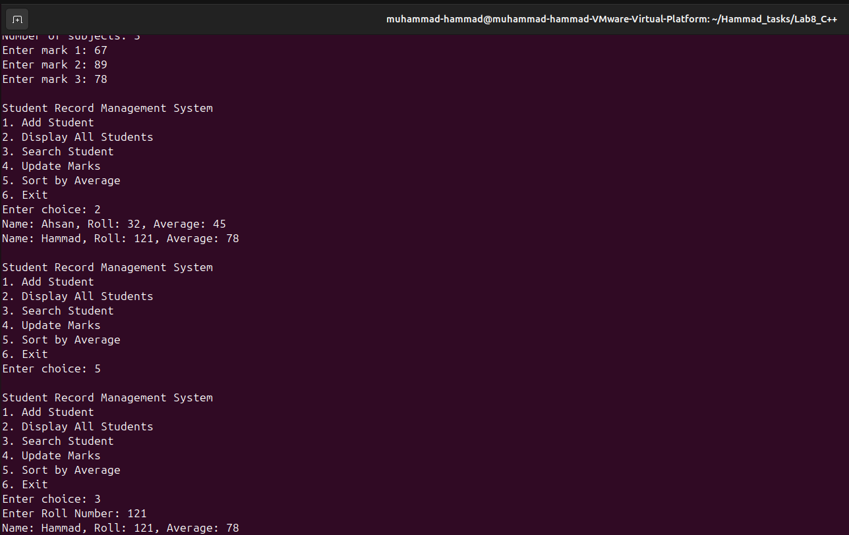
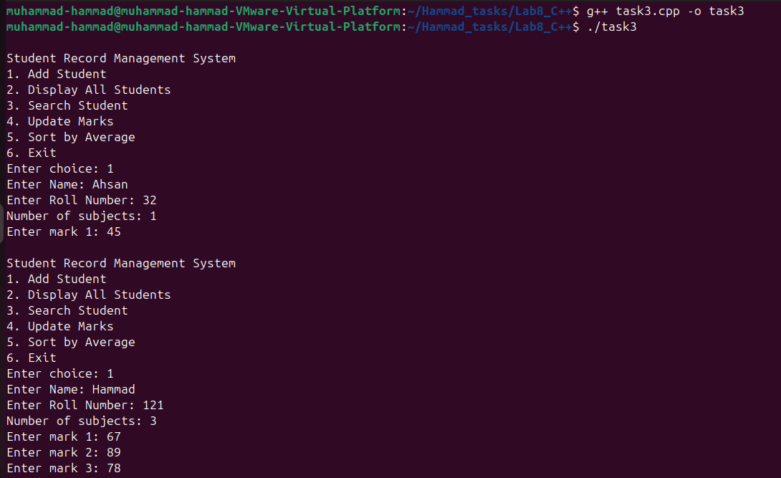
OUTPUT

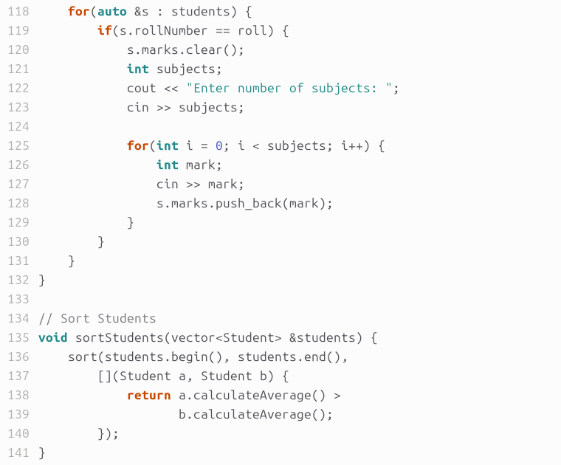
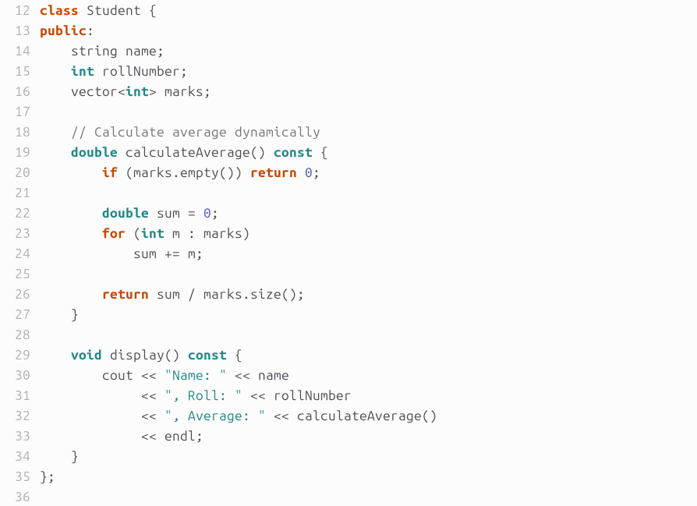
CODE

Task 04 – Description
This task illustrates the use of the this pointer in a BankAccount class to access object members and enable method chaining. It performs deposit, withdrawal, and display operations efficiently using returned this pointer.

TASK#04
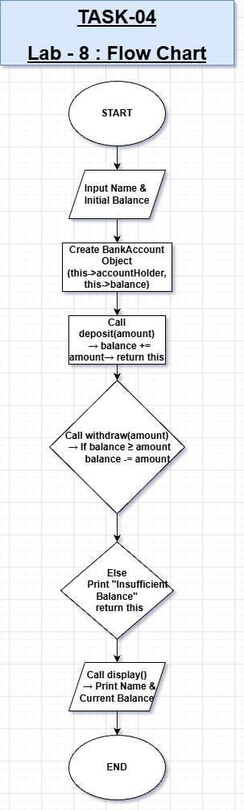

CODE
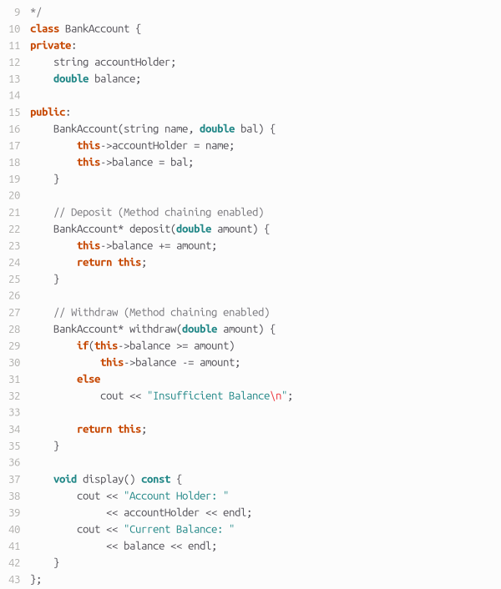

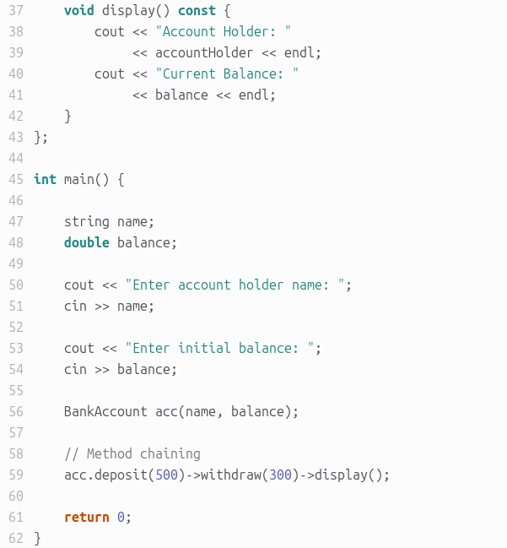

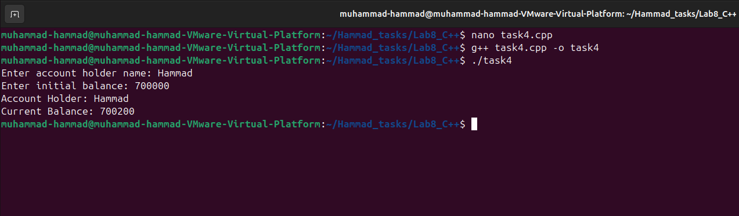
OUTPUT

CONCLUSION:

Overall, this lab strengthened the understanding of core C++ OOP concepts including inheritance, virtual functions, dynamic binding, vectors, and the this pointer. It also provided practical experience in designing modular, reusable, and menu-driven programs following object-oriented programming principles.

